Documentation for the Visual programming project

1. Description of the project

* In this project I made the game Blackjack. This game is played between the player and the dealer. The core objective of this game is to have a hand score as close to 21 without exceeding it. Every card in this game has unique value except for Ace. The cards from number 2 to 10 are worth their face value, the face cards (Jack, Queen, King) are worth 10 and the Ace can be either 1 or 11 depending on the situation. If the total hand value exceeds 21(the sum of all values of the cards) the Ace that comes in the hand cards is going to have value of 1.
* When we start the game, we can see the round chips that have different value and by clicking some of the chips we can place a bid. Then we have the player’s total money label and 2 buttons - Cash-out and All-in.

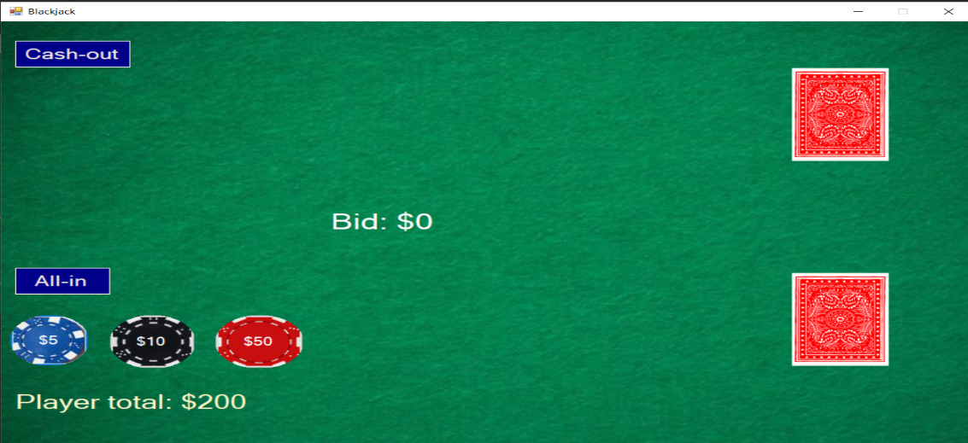

* If we click the button Cash-out the game ends with a message box that shows the total money that the player earned.
* If we click on All-in, then all the player’s total money will be put as a bid.
* After clicking All-in, the button “DEAL” appears. This button also will show up after putting bid by clicking on some of the round chips.

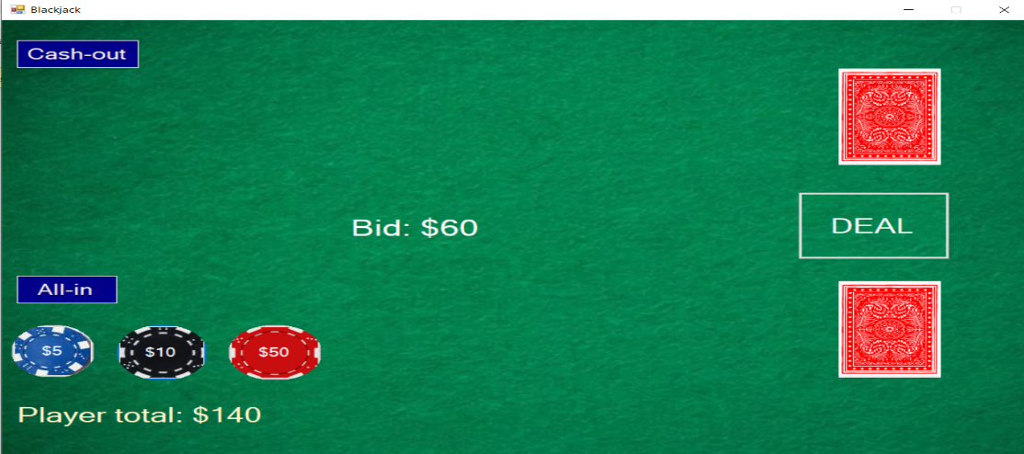

After clicking the button “DEAL” the dealer starts dealing two cards to the player and two to themselves. One of the dealer’s cards is face down and the other is face up. The player’s cards are both face up. After arriving the first two cards, the player score is updated and immediately the other two cards start to move.

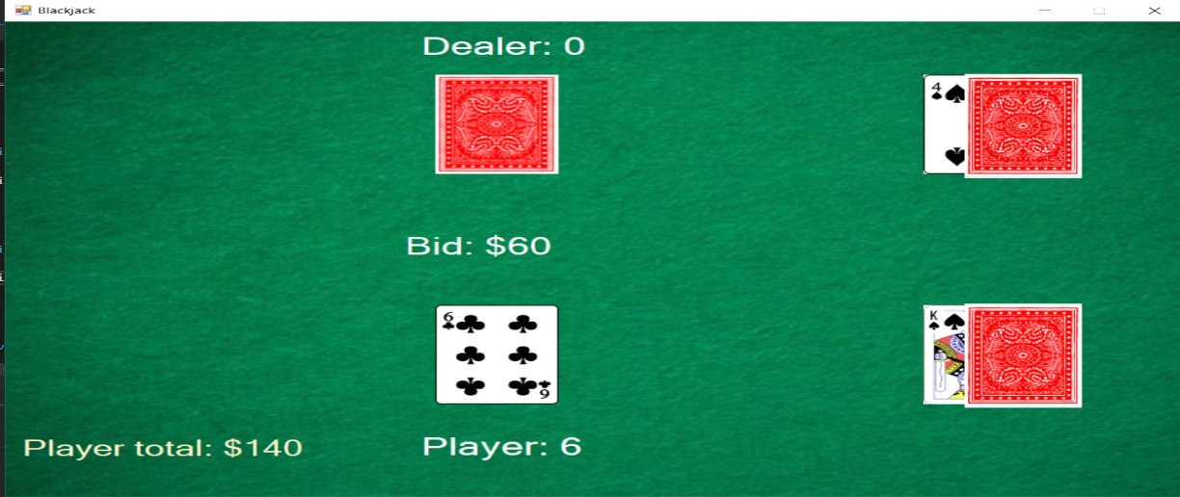

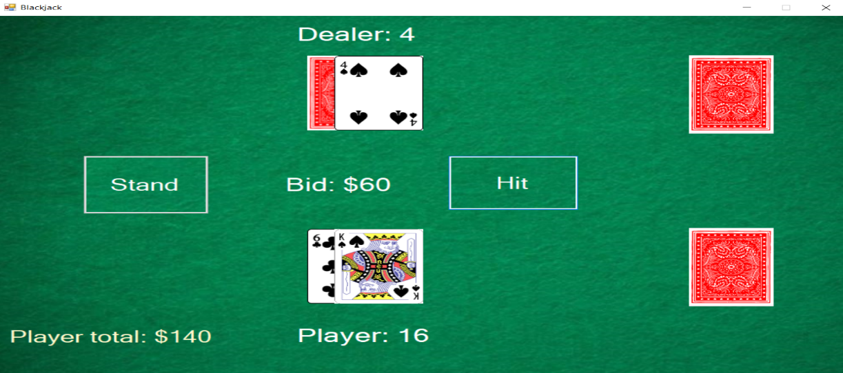

After all 4 cards arrive at their proper position, we can see the total score of the face cards of both player’s and dealer’s hand and, we can see the “Hit” button and “Stand” button.

* The player can make decisions based on the total value of their hand and the visible dealer’s card. The options are “Hit” and “Stand”.

1. If the player chooses “Hit” then a new random card comes from the deck. After picking a new card, the total score of the hand is recalculated. If the score is greater than 21, then the player automatically loses the bid, and a message box appears.

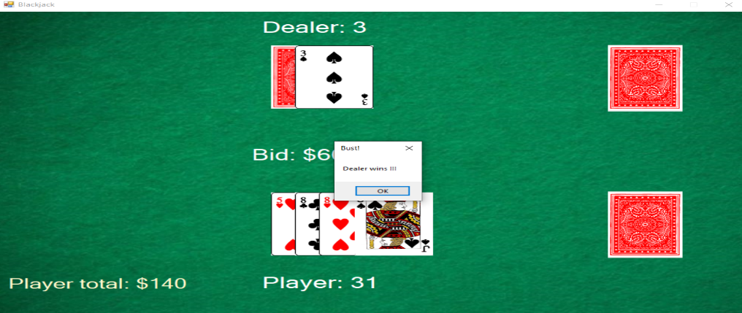

1. If the player chooses “Stand” then that means that he is satisfied with their hand and that they don’t need any more cards. After choosing “Stand”, it’s the dealer’s turn to play. The dealer reveals his face-down card. If the dealer’s hand is better than the player’s hand (the dealer’s score is greater than player’s score), the dealer wins.

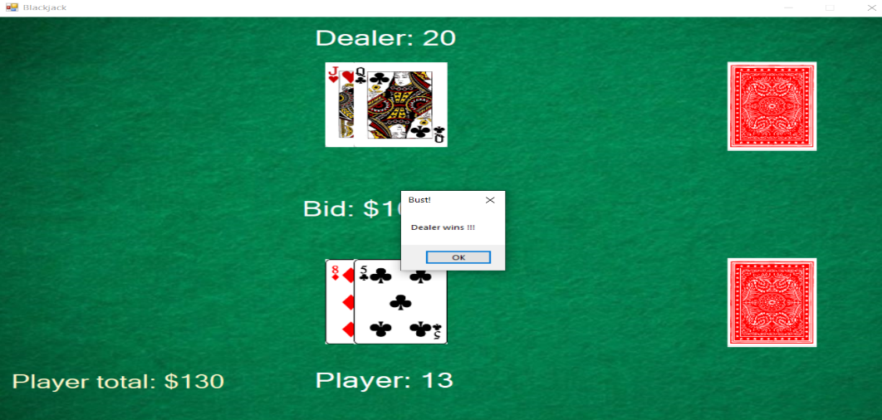

-If not, the dealer picks random cards from the deck until they have a better hand (greater score) than the player’s hand. If the dealer score exceeds the number 21 while trying to get a greater score than the player score, then the player wins and gets double the bid. If the player and the dealer both have 21, that means that no one won, and the player gets his original bet back.

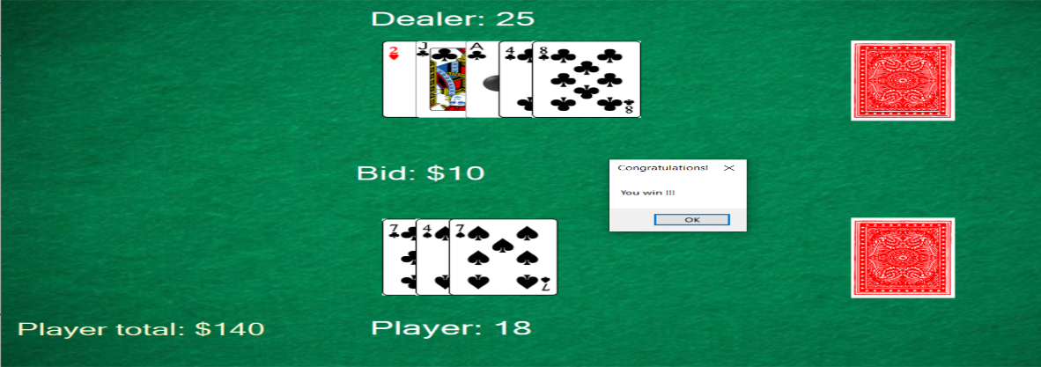

* If we have a player total that is less than any of the round chips, then they disappear from the table. For example, if the total player’s money is less than 50, the chip with value 50 will disappear from the table. This will happen also for the other chips if the total money is less than their value.

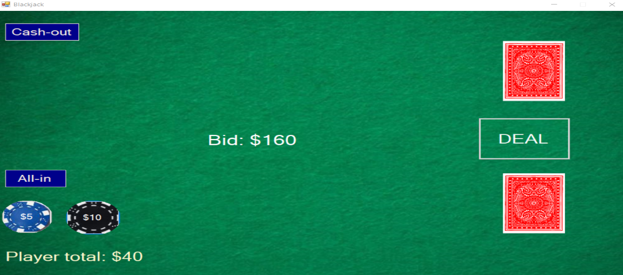

* If a player loses all money, then a message box appears that allows us to start a new game.

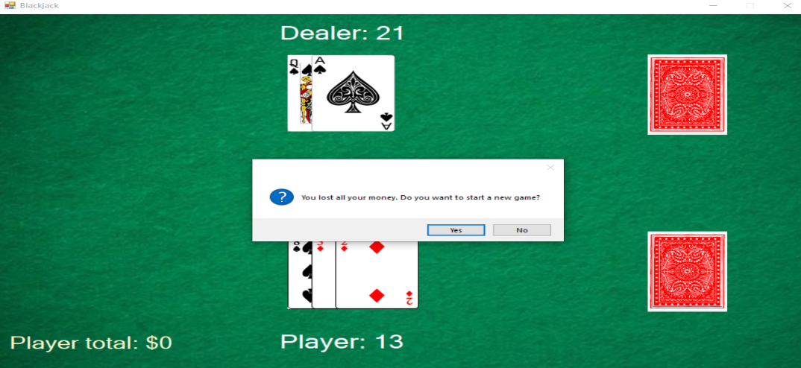

1. To make this game, I used a class Player where I store the player’s total money which by default is 200, the list of the cards in the player’s hand and the score. Another class is the class Dealer where I store the same attributes as the player except for the total money. Then I have class Scene where I store all the Cards from deck in a list, then I have instances of the class Player and the Dealer, the Bid, and all the ranks and suits (signs) of the cards in different arrays. I also have class Card where I store the image of the card, the rank, the suit, the value of the card and positions of the player’s and the dealer’s cards. In the constructor of the Scene class, I set the images for all the cards by retrieving them from the resources folder in the project. In the Form class I use 3 timers. One timer for the first four cards that come after clicking Deal, another timer for the Hit function and another for the Stand function. After clicking Deal, I call the function generateFirstRandomCards() which starts the timer and generates the first two cards for the player and the first two for the dealer. In the timer tick event, I use two boolean variables that determine which cards need to be moved from the deck. For example, as the timer starts, the first two cards start moving and when the timer ticks are equal to 30, the first 2 cards stop moving and the other two start to move towards the player’s and dealer’s hand. In the hit timer I move the random generated card that is generated when we click the Hit button and I also check if the total score of the Player exceeds 21.